|  |  |
| --- | --- |
| **Assessment** | **Assignment 01** |
| **Subject** | **Web Engineering - SESD3233** |
| **Subject Teacher** | Ms. Areesha Sajjad, Ms. Rubab Javaid, Mr. Zahid Husnain, Mr. Usman Akbar |
| **Deadline** | **13th April 2025 (11:00 PM)** |
| **Total Marks** | **20 Points** |
| **Topic Coverage** | **HTML Basic Tags, Lists, Links, Tables, Forms, Images** |
| **Assignment Policy**   * All submissions will be on **UCP Portal** only. Upload zip files of code + all Code on **Ms-Word file** with all codes by sequence of questions. * No acceptance on Email/WhatsApp or other medium. * No assignment will be accepted after the due date. So, upload your assignment as soon as possible before the due date. * All the parties involved in the first **cheating case** will be awarded **ZERO** for that evaluation. Afterwards, all students involved in the **second instance** will be awarded **ZERO in the entire evaluation category.** | |

**CLO-1 :** Students will be able to design and develop responsive web pages using HTML and CSS, applying semantic elements, flexbox, grid layouts, and responsive design techniques to build structured and visually appealing user interfaces.

|  |  |
| --- | --- |
| **Q1** | **CLO-1** |

**Question 01 (A):** **(05 Marks)**

Design and implement an HTML table structure to effectively present tabular data. Populate the table with meaningful data relevant to the context. Ensure proper use of table elements and formatting to enhance readability and usability.

*Note: Use inline CSS for styling*

|  |  |  |  |  |  |
| --- | --- | --- | --- | --- | --- |
| **Data Table (Header)** | | | | | |
| **DATA 1** | **101** | **UN-ORDER LIST**   * BBB * AAA * 333 * 0000 | | **Heading 1** | **Heading 2** |
| **201** | **Heading 3** | **Heading 4** |
| **301** | 302 | **UCP Portal >>** <https://horizon.ucp.edu.pk/web/login> | | |
| **DATA 2** | **D11** | D12 | **ORDERED LIST**   1. D13 2. D14 3. D15 4. D16 5. D17 | | UCP Logo |
| **D21** | D22 |  |
| **D31** | D32 | **UCP Website >>** <https://ucp.edu.pk> | | |
| **Data Table (Footer)** | | | | | |

**Question 01 (B): (15 Marks)**

Develop an HTML forms for product module in online-store by using a table-based layout to ensure a structured and visually organized web page. Implement appropriate form elements, including input fields, dropdowns, and buttons, while maintaining proper alignment and accessibility.

*Note: Use internal CSS for styling and use your owm imagination for web page coloring and styles.*

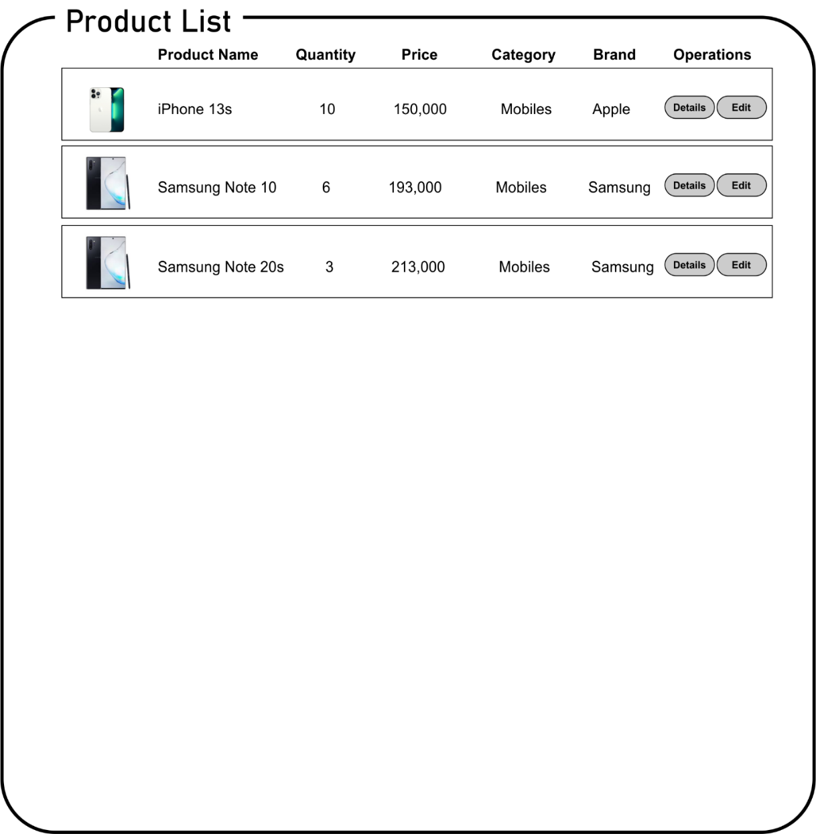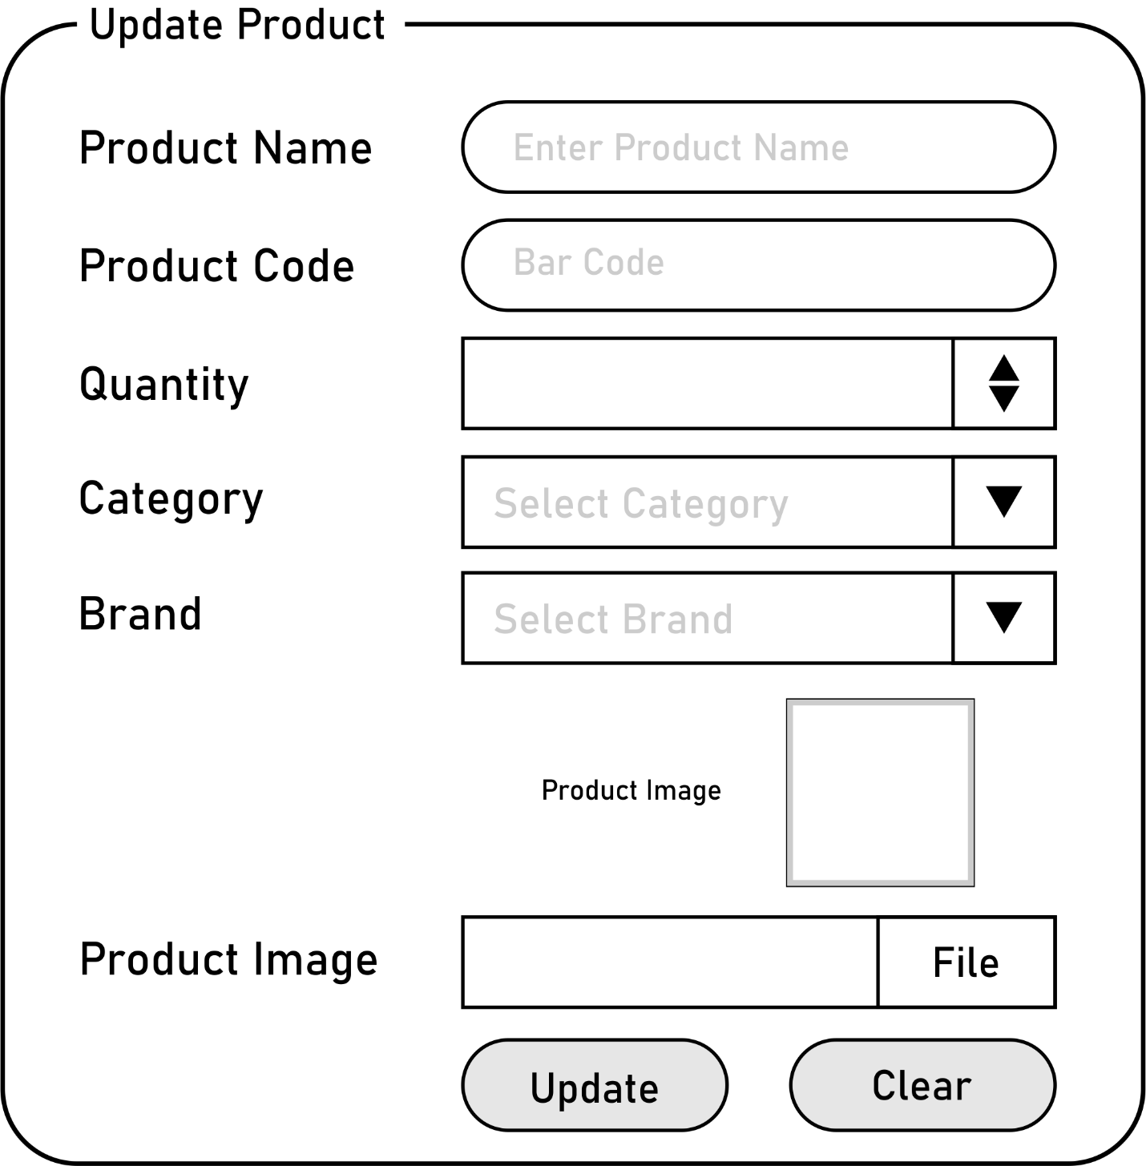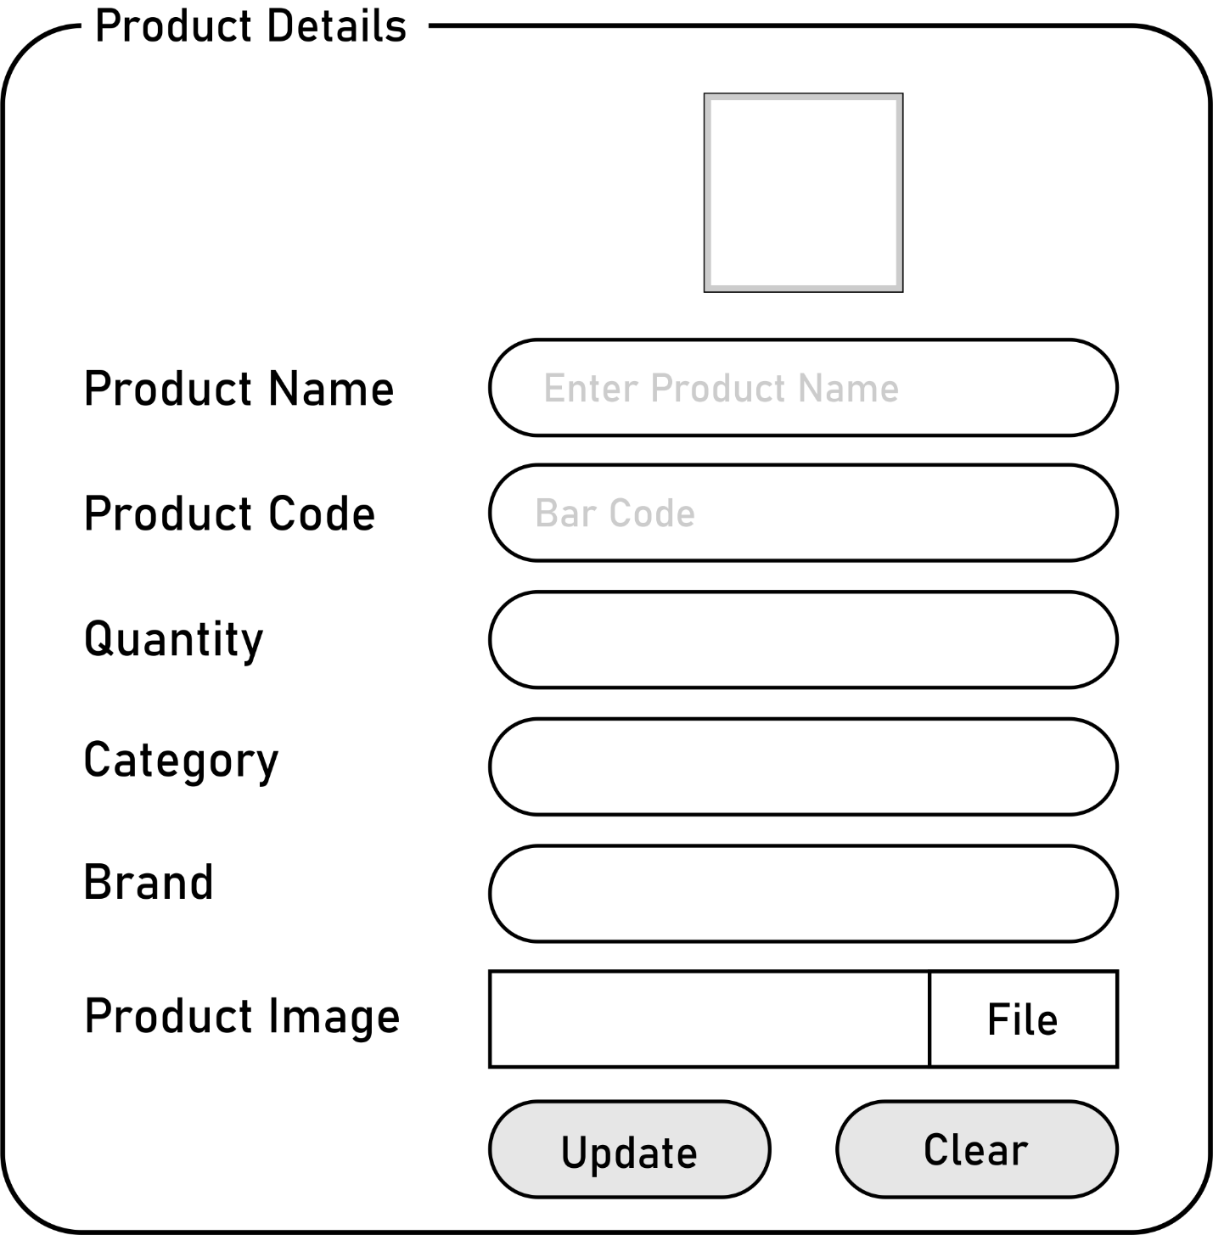

Best of luck 😊